Docker Assignment

**Requirements**

• Docker 20.10 or later

• Docker Compose 1.29 or later

• Linux command-line knowledge

• GitHub account

**Step-by-step instructions & documentation for your Docker assignment**  
**Install Docker and Docker Compose on your machine**  
**Steps:**

* Go to the official Docker Desktop for Windows download page:  
  https://docs.docker.com/desktop/install/windows-install/
* Download the installer.
* Run the installer and follow the installation prompts.

**Verify Installation**

**Create a simple web and write a Docker file to containerize the application.**

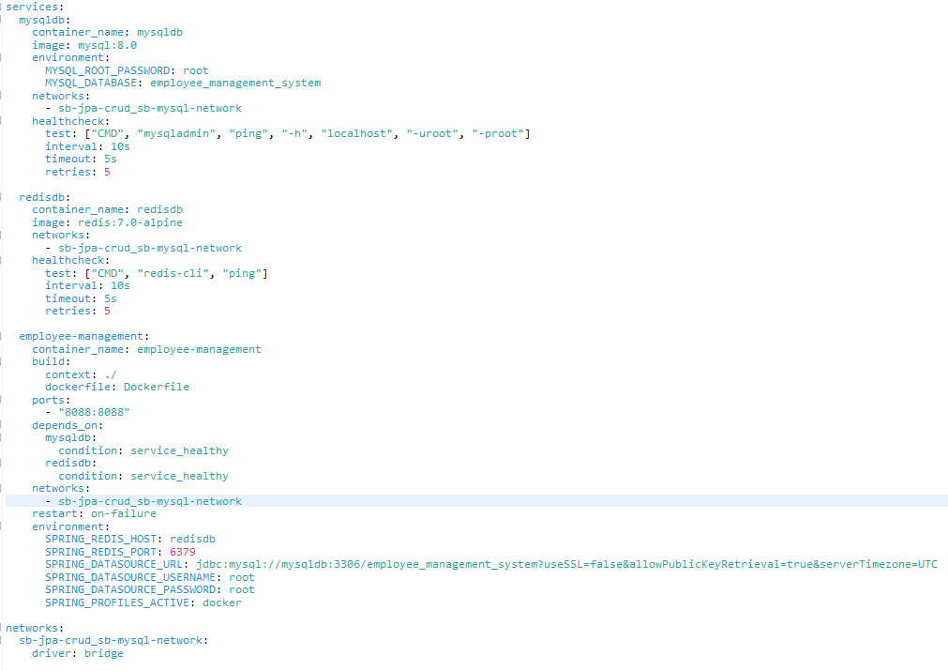

**Build the Docker image and run a container from it.**

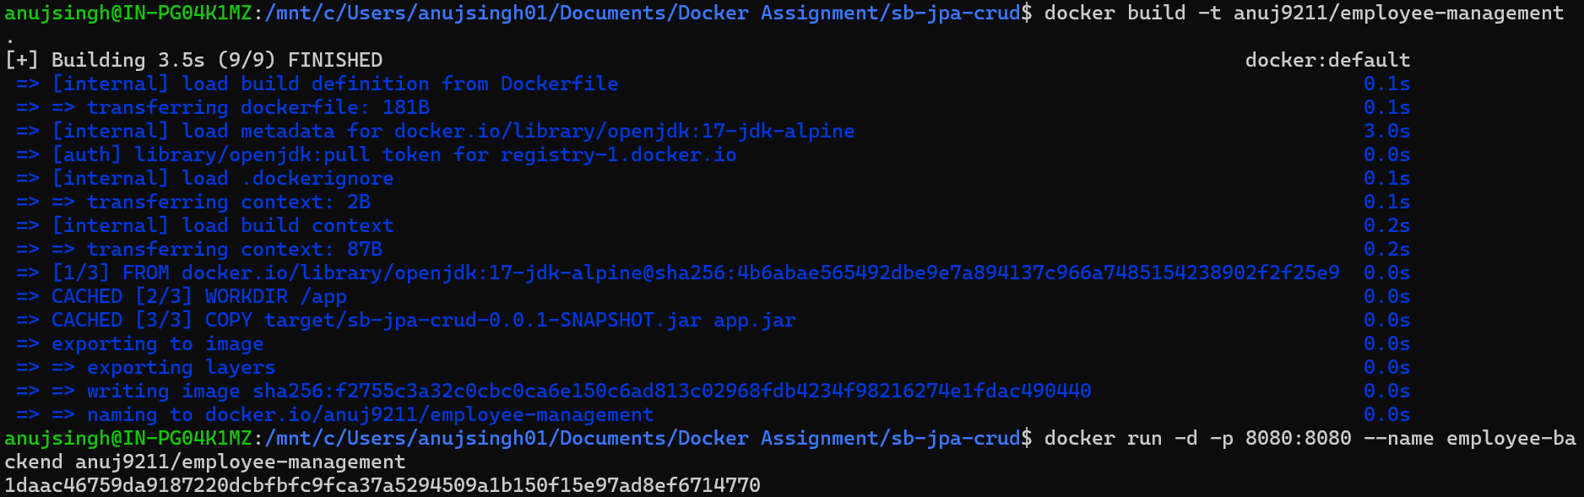

**Use Docker commands to list, start, stop, and remove containers.**

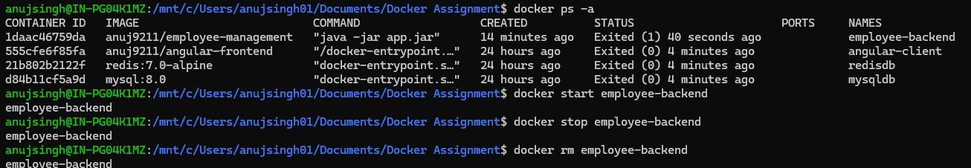

**Inspect running containers and view logs.**

**Write a docker-compose.yml file to define a multi-container application**

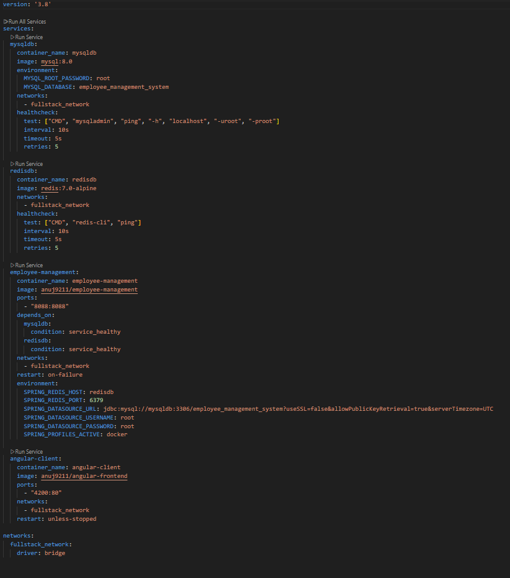

**Use Docker Compose to bring up the application and ensure all services are running correctly.**

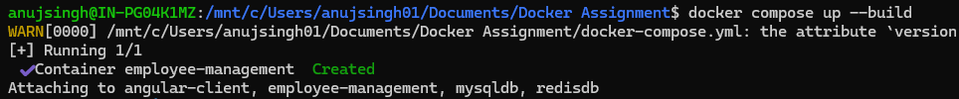

**Create a private Docker registry or use Docker Hub.**

**Push your Docker images to the registry.**

**Pull the images from the registry and run them locally.**

